**Superstore Sales**

Section 1: Basic Formatting

* Increase the column widths to appropriate sizes so that they are readable
* Format the header row in a suitable colour and put borders around the header row cells

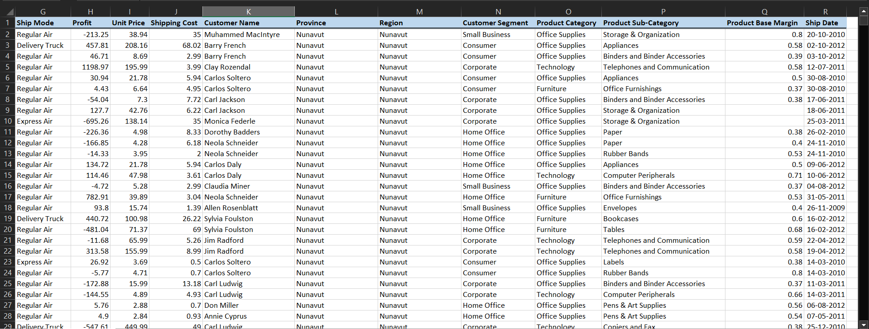

Section 2: Filtering

* Filter the data by customer segment
* Create four new worksheets, one for each customer segment
* Copy raw data of each customer segment into the respective worksheet



Section 3: Report Making - I

* Freeze the header row
* Delete or hide any unwanted columns
  + Hint: Decide judiciously between which columns should be deleted / hidden
* Round off sales and profits to one decimal place
* Format sales and profit in US dollar units
* Format the Order Date and Ship Date into a more readable format (say 15-Jan 2012, or choose a format that you find the most readable) Section 4: Report Making - II
* **Sorting:**
* Sort alphabetically by Region
* Within Region, sort alphabetically by Province

Within Province, sort in decreasing order of sales

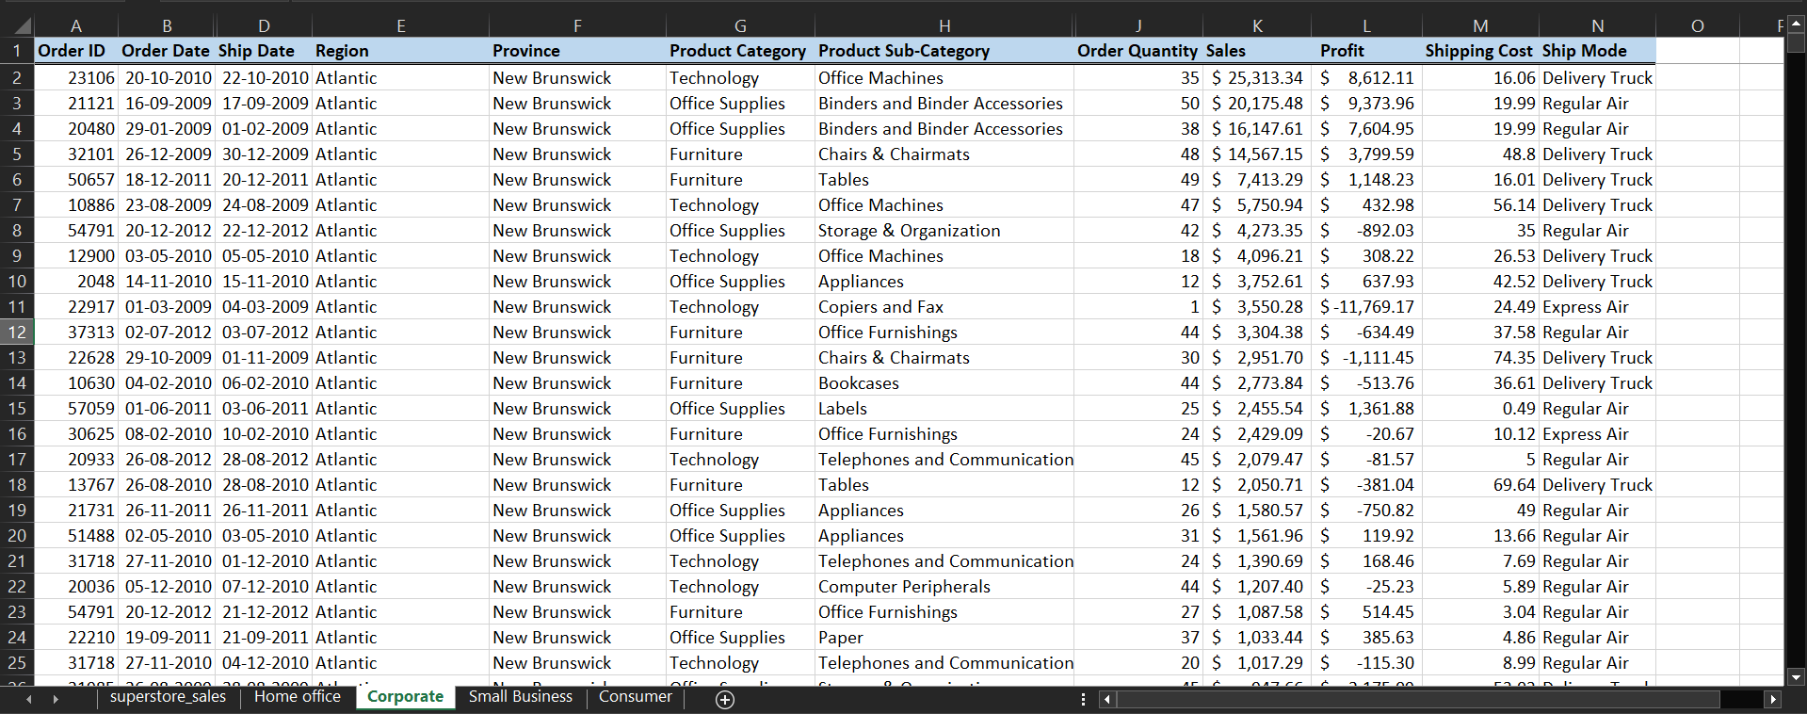

Conditional Formatting - I:•Within every Region, highlight the top 10% orders by sales in light green fill and dark green border.

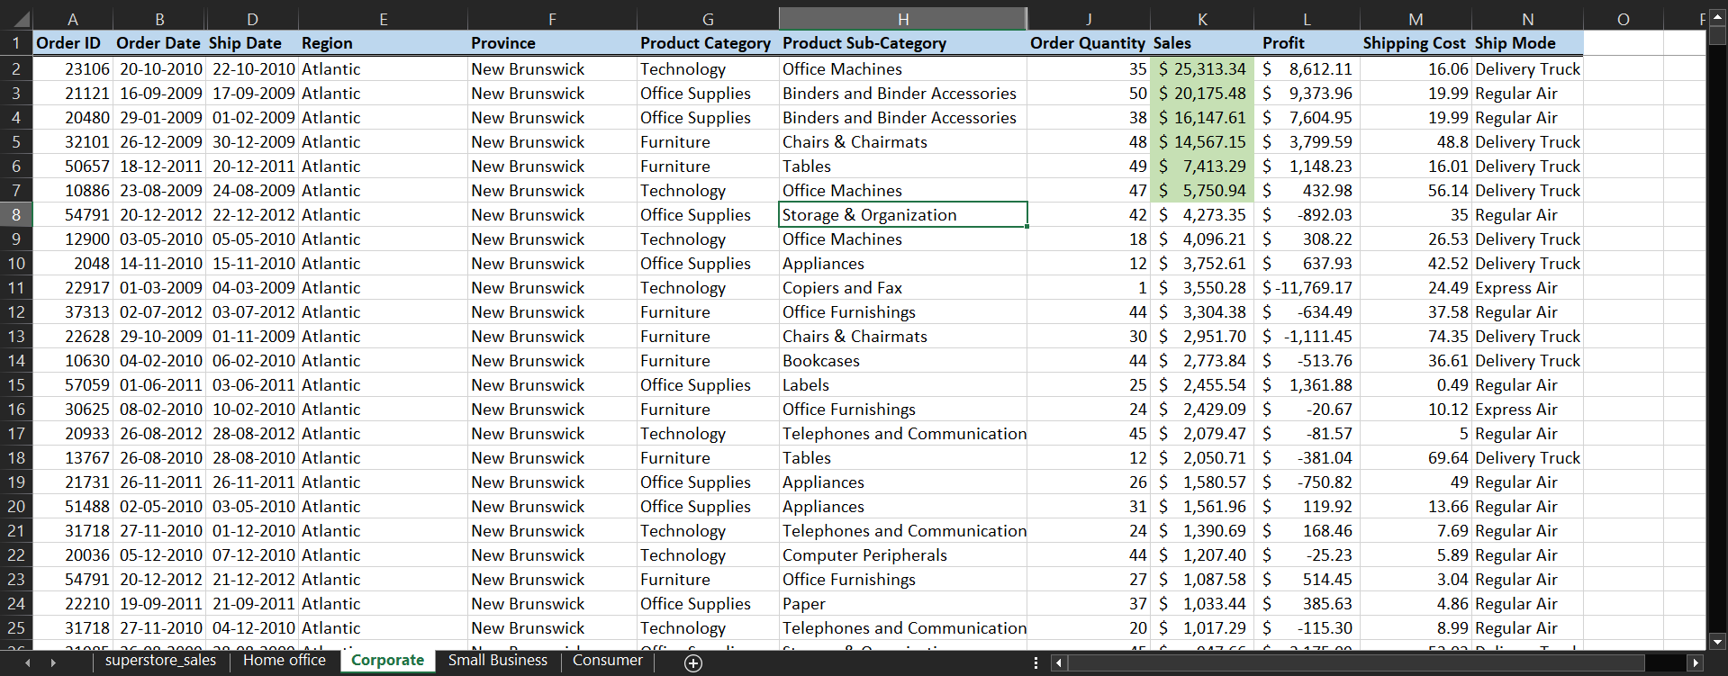

**Conditional Formatting - II:**

* To help your manager understand profits better, highlight profits in a scale of green and losses in a scale of red (Higher the profit, darker the shade of green; More the loss, darker the shade of red).
  + **Learning Tip**: Learn how to apply multiple conditional formatting in one column.

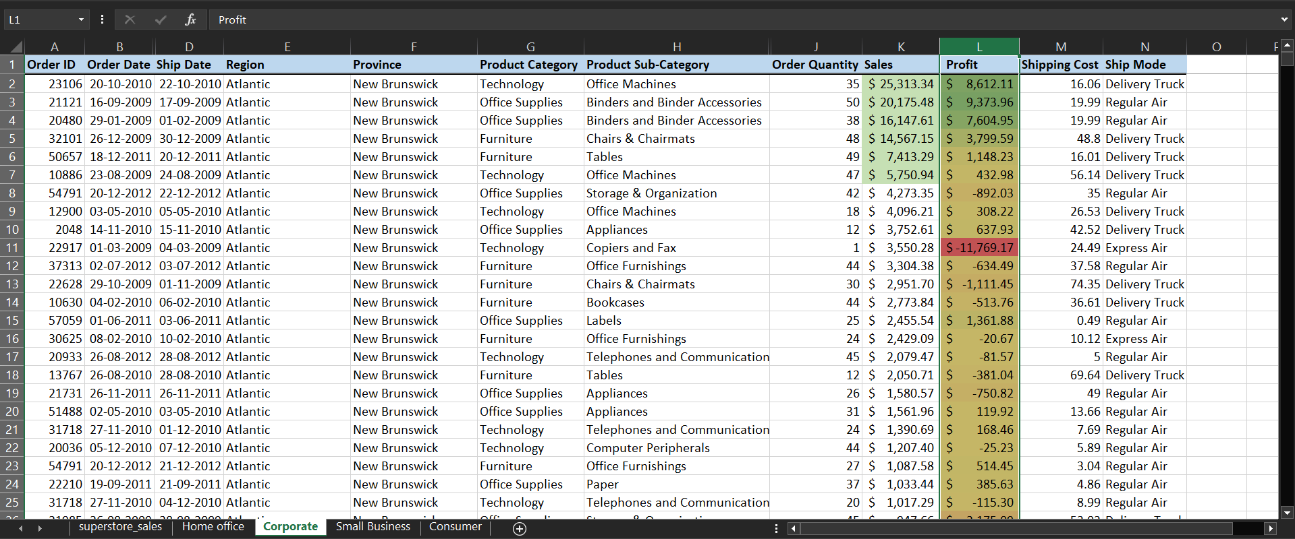

 Printing, Saving and Exporting to PDF

* Experiment with different page layout options to fit the report in minimum number of pages
* Apply password protection to the worksheet

Save a printable version

